**“EARLY PREDICTION OF LIFESTYLE**

**DISEASES”**

**A Project Phase – I Report**

**YEAR 2021-22**

**Submitted in partial fulfillment of the requirement for the award of Degree of Bachelor of Technology in Computer Discipline**

**Submitted To**



**DR.BABASAHEB AMBEDKAR TECHNOLOGICAL UNIVERSITY, LONERE**

**Submitted By:**

|  |  |
| --- | --- |
| **Mr. Jayesh Ramkant Patil** | **PRN No. 21516420181124510031** |
| **Mr. Milind Bhagwan Mahire** | **PRN No. 21516420181124510022** |
| **Mr. Lalit Gulabroa Nikam** | **PRN No. 21516420181124510039** |
| **Mr. Rushikesh Ramu Patil** | **PRN No. 21516420181124510041** |

**Under The Guidance Of:**

**Prof. Shezad Sheikh**



**DEPARTMENT OF COMPUTER ENGINEERING**

**P.S.G.V.P. MANDAL’S**

**D.N.PATEL COLLEGE OF ENGINEERING**

**SHAHADA, DIST- NANDURBAR (M.S.)**

**P.S.G.V.P. MANDAL’S**

**D. N. PATEL COLLEGE OF ENGINEERING**

SHAHADA, DIST- NANDURBAR (M.S.)

CERTIFICATE



***This is to certify that***

|  |  |
| --- | --- |
| **Mr. Jayesh Ramkant Patil** | **PRN No. 21516420181124510031** |
| **Mr. Milind Bhagwan Mahire** | **PRN No. 21516420181124510022** |
| **Mr. Lalit Gulabroa Nikam** | **PRN No. 21516420181124510039** |
| **Mr. Rushikesh Ramu Patil** | **PRN No. 21516420181124510041** |

***Has* *satisfactorily completed Project Phase-I entitled***

#### “Early prediction of lifestyle diseases”

**As prescribed by Dr. Babasaheb Ambedkar Technological University, Lonere as a part of syllabus for the partial fulfillment in Bachelor of Technology in Computer for Academic year 2021-22.**

**GUIDE H.O.D.**

Prof. **Shezad Sheikh** Prof. V. S. Mahajan

**EXAMINER PRINCIPAL**

**___________** Prof. Dr. N.J. Pati

ACKNOWLEDGMENT

The Acknowledgement is just like a drop in the ocean of the deep sense of gratitude within our heart for people who helped us out of most embarrassing part of our life when we were standing at most difficult step towards our dream of life. Many people have contributed to the success of this project work. Although a single sentence hardly suffices, we would like to thank Almighty God for blessing us with his grace. We extend our sincere and heartfelt thanks to **Prof. V. S. Mahajan**, Head of Department, Computer Engineering, for providing us the right ambience for carrying out this work.

We are grateful and sincerely appreciate the effort of our respected project in-charge **Prof. V. T. Patil** and **Prof. L. M. Kuwar** who acted as a fulcrum for us and supported us during the ups and downs of our project.

We are profoundly indebted to our project guide **Prof. Shezad Sheikh** for innumerable acts of timely advice, encouragement and we sincerely express our gratitude to him. We express our immense pleasure and thankfulness to all the teachers and staff of the Department of Computer Engineering for their cooperation and support.

Jayesh Ramkant Patil

Milind Bhagwan Mahire

Lalit gulabroa nikam

Rushikesh Ramu patil

ABSTRACT

**L**

*ifestyle diseases are common among the population today not only in India but also in almost every country. Lifestyle diseases are caused because of the habits that we have on a day to day basis. The way one lives his life is the major cause of it. It includes heart disease, hypertension, etc. which all may hear of. In our life also, one also comes across at least one person who is either suffering from such diseases or the diseases became the reason for his death. We also came across many such people who died because they were not aware of their disease and were left with no appropriate time for treatment.*

*That is why we decided to develop the portal which will analyse the data entered by the user and will give the predictions of the diseases which he or she may have chances to su_er from. This not only gives the predictions but also gives you the preventive measures that are required to stay safe from the very common lifestyle diseases as well as in case of mild symptoms it provides you with the management techniques also. This project makes the person aware of his health so that he will have the treatment well in time if required and will save the lives of many people. This project covers three main aspects which are prediction, prevention and management of lifestyle diseases.*

***Keywords:-*** *Lifestyle diseases, death,treatment, common lifestyle, prediction, preven-*

*tion, management .*

TABLE OF CONTENTS

|  |  |  |  |  |
| --- | --- | --- | --- | --- |
| **Chap**  **No.** |  |  | **Content** | **Page**  **No.** |
|  | | | | |
| **-** | **ACKNOWLEDGMENT** | | | **3** |
| **-** | **ABSTRACT** | | | **4** |
| **-** | **TABLE OF CONTENTS** | | | **5** |
| **-** | **LIST OF FIGURES** | | | **6** |
| **-** | **LIST OF TABLES** | | | **6** |
|  |  | | |  |
| **1.** | **INTRODUCTION** | | | **7** |
|  | 1.1 | Introduction to Project Domain | | 7 |
|  | 1.2 | Background | | 7 |
|  | 1.3 | Motivation | | 8 |
|  | 1.4 | Problem Definition | | 8 |
|  | 1.5 | Scope | | 8 |
|  | 1.6 | Objectives | | 9 |
|  | 1.7 | System Methodology | | 9 |
|  | 1.8 | Architecture | | 11 |
| **2.** | **LITERATURE SURVEY** | | | **13** |
| **3.** | **ANALYSIS** | | | **15** |
|  | 3.1 | Feasibility Study | | 15 |
|  |  | 3.1.1 | Technical Feasibility | 15 |
|  |  | 3.1.2 | Economic Feasibility | 15 |
|  | 3.2 | Project Planning & Scheduling | | 16 |
|  |  | 3.2.1 | Team Structure | 16 |
|  |  | 3.2.2 | Timeline Chart | 16 |
|  |  | 3.2.3 | Project Table | 17 |
|  | 3.3 | Requirement Analysis | | 18 |
|  |  | 3.3.1 | Software Process Model | 18 |
|  |  | 3.3.2 | Functional Requirements | 19 |
|  |  | 3.3.3 | Non-functional Requirement | 20 |
|  |  | 3.3.4 | Hardware Requirements | 20 |
|  |  | 3.3.5 | Software Requirement | 20 |
|  | 3.4 | Analysis Modeling | | 21 |
|  |  | 3.4.1 | System Architecture | 21 |
|  |  | 3.4.2 | E-R Diagram | 21 |
|  |  | 3.4.3 | Data Flow Diagram | 22 |
|  |  |  | 3.4.3.1 DFD - Level 0 | 22 |
|  |  |  | 3.4.3.2 DFD - Level 1 | 23 |
| **4.** | **DESIGN** | | | **24** |
|  | 4.1 | Introduction | | 24 |
|  | 4.2 | UML Modeling | | 24 |
|  |  | 4.2.1 Use Case Diagram | | 24 |
|  |  | 4.2.2 Sequence Diagram | | 26 |
|  |  | 4.2.3 Collaboration Diagram | | 29 |
|  |  | 4.2.4 Activity Diagram | | 30 |
|  |  | 4.2.5 Class Diagram | | 32 |
|  |  | 4.2.6 Components Diagram | | 33 |
|  |  | 4.2.7 Deployment Diagram | | 34 |
| **5.** | **CONCLUSION** | | | **36** |
|  | 5.1 | Conclusion | | 36 |
|  | 5.2 | Future Work | | 36 |
| **-** | **REFERENCES** | | | **37** |

**LIST OF FIGURES**

|  |  |  |  |
| --- | --- | --- | --- |
| **Sr.**  **No.** | **Figure No.** | **Figure Name** | **Page No.** |
|  |  | | |
| **1.** | 3.2 | Timeline Chart | 17 |
| **2.** | 3.4 | Waterfall Model | 19 |
| **3.** | 3.5 | System Architecture | 21 |
| **4.** | 3.6 | ER Diagram | 22 |
| **5.** | 3.7 | Data Flow Diagram – Level 0 | 23 |
| **6.** | 3.8 | Data Flow Diagram – Level 1 | 23 |
| **7.** | 4.1 | Use Case Diagram | 25 |
| **8.** | 4.2 | Register Login Logout Sequence Diagram | 26 |
| **9.** | 4.3 | User ( People ) Sequence Diagram | 27 |
| **10.** | 4.4 | Doctors Sequence Diagram | 28 |
| **11.** | 4.5 | Admin Sequence Diagram | 29 |
| **12.** | 4.6 | Collaboration Diagram | 30 |
| **13.** | 4.7 | Activity Diagram | 31 |
| **14.** | 4.8 | Class Diagram | 33 |
| **15.** | 4.9 | Component Diagram | 34 |
| **16.** | 4.10 | Deployment Diagram | 35 |

**LIST OF TABLES**

|  |  |  |  |
| --- | --- | --- | --- |
| **Sr.**  **No.** | **Table No.** | **Table Name** | **Page No.** |
|  |  | | |
| **1.** | 3.1 | Team Structure | 16 |
| **2.** | 3.2 | Timeline Chart | 17 |

Chapter 1

INTRODUCTION

# **INTRODUCTION TO PROJECT DOMAIN**

Today, people do not have time for the regular checkup. They are so busy with their work that they rarely have time for their own health. But the thing is that, they can do the analysis if the appropriate application can provide them the overall health status of the person. This is because they need not to give the time separately for this, rather they can just utilise the time for example the time of travelling, etc. The only thing required is the smartphones which almost everyone has with them in this century. So, this can be considered as the portable health checker which everyone can use easily just through a web application. In this, we have decided to give the sign up page where the user can sign up using his name, id and password. Then further modules will have the diseases portion. Though the wholehealth check is a somewhat more difficult task, so initially we are adding some of the very common diseases data like heart disease, breast cancer, etc. Later on, we will keep adding more and more diseases.

# **1.2 BACKGROUND**

          Prediction Of the disease during the pandemic is critical for public health planning of efficient health care allocation and monitoring the effects of policy interventions.

In another study,  an algorithm is proposed to achieve local updates and global updates which is critical for the learning process.  ML/AI  is also used to solve wireless network problems. Cheat al. represented how artificial neural networks can be used to solve various problems in wireless networks.

               Diabetes has been in society for a  very long time. Diabetes is further dependent on an individual's body,  diet, and way of living.  In another study,   pre-diabetes is predicted using different applications on the  Korean population.

            Death in intensive care units  (ICU s )  worldwide and its recognition,  particularly in the early stages of the disease, remains a   medical challenge.

# **1.3 MOTIVATION**

Lifestyle diseases are common among the population today not only in India but also in almost every country. Lifestyle diseases are caused because of the habits that we have on a day to day basis. The way one lives his life is the major cause of it. It includes heart disease, hypertension, etc. which all may hear of. In our life also, one also comes across at least one person who is either suffering from such diseases or the diseases became the reason for his death. We also came across many such people who died because they were not aware of their disease and were left with no appropriate time for treatment. That is why we decided to develop a portal for showing early disease information and solutions or precautions.

# **1.4 PROBLEM DEFINITION**

In this platform, the people and doctors are joined and they are registered login logout and also they have early knowledge of what is happening in their area and the true information is given to this platform. About the disease which is a large amount of spearing in this area first of all the people see and their area which diseases is spread and also check their symptoms, also in bottom, and also give what the precaution do for the disease not come, also if you have any other disease then also have a chatbox to say your problem there was the best doctor, and they convey you to what to do for these diseases. And also doctors joined this platform as a sub-admin. They solve the people’s posted questions, and also add current disease information and safety tips and what precautions we do for these diseases and also know about these doctors who give this information. Admin doctor verifies this doctor’s added information and verifies the doctor’s status and manages the site settings.

# **1.5 SCOPE**

       This project will help the user to overcome the lifestyle diseases which are in themselves a big threat to humans, will reduce the unawareness about the diseases and will help people to remain healthy which is of utmost importance in today’s fast-growing world. It will also change the lifestyle of people for the better. It will also give clarity about the health of a person or his current status.

In future mostly AI and ML is going to be implemented everywhere. Everyone will get so busy with their work that they will not get enough time to visit the doctor. Exceptionally when they get serious. But will ignore the minor and common disease which will eventually become more serious in future. Like in tuberculosis, a person starts to cough and only with preventive measures they can be submerged at that time.so this app will become more and more common in future. Without visiting doctors' people will get to know about their symptoms.

# **1.6 OBJECTIVE**

* Easy identification of any disease.
* Treatment from home is easy for us.
* The online treatment gives us a cost-saving and time-saving solution.
* Treatment is from a multispeciality hospital.
* Treatment is simple and secure.
* Installable in Mobile as well as Desktop.

# **1.7 SYSTEM METHODOLOGY**

Data Mining is a technique of analysing the huge amount of data in different aspects to discover the useful information or the knowledge discovery. It combines the concepts of artificial intelligence, statistics, probability, machine learning, deep learning and database system technology.

The processes of data collection, selection, cleaning handling the missing values, transformation, mining, evaluation of pattern, and knowledge visualization involved in data mining process. The data is increasing exponentially so as in the case of the health sector.

Logistic regression is way more similar to the linear regression in terms that they both gives the relationship between the variables. For the construction of the curve of logistic regression one can use the natural logarithm of the odds against the target variable, rather than just calculating the probability. There are various techniques already available for the regression application some of which can be Generalized Linear Models (GLM), Support Vector Machines (SVM), Ordinary sum of squares (ESS), etc. GLM is used for linear modelling, SVM for linear, nonlinear as well as other mining functions and SEE for the ordinary linear relationship between the variables. For analysing the medical data, regression turns out to be the most important statistical method (especially using the covariance method) as it establishes the relationship between multiple variables which can be SISO (Single Input Single Output), MISO (Multiple Input Single Output).

A Cluster is a collection of the similar objects which are unsupervised. It doesn’t have pre-defined categories. K-means, kernel K-means, Gaussian mixture models, clustering, K-nearest neighbor are few examples of algorithms for clustering.

Decision tree gives the presentation of the gathered knowledge. Transformation of leaf nodes to a set of rules by mapping from the root node to the leaf nodes one by one is easy. The result of the decision trees is observed to be highly accurate in case of classification which makes it more reliable and an effective decision-making technique which can suitably be used for medical diagnostics. Formore than 20 years, researchers are using these decision trees in medical and health care applications. Some of the instances of the classical decision tree algorithms are CART, ID5R., SADT, and OCI. Hybrid approach is developed to reduce the drawback of the decision trees a by combining the decision trees with the artificial neural networks.

ANN are computational models which are developed parallel to the biological model of the human brain. These are the nonlinear data modelling tools which are quite complex in nature and are also flexible to apply on incomplete, missing and noisy data. When under lying data, relationship is unknown the ANN is the most powerful tool which can be used in the given situation for data modelling. High efficiency and performance can be achieved by combining the ANN with nervously systems and the genetic algorithms.

***A. For the starting module:***

* For this, we will open the app with its logo and ask the user to sign in.
* In this module, we will be creating a menu driven page with several options for the user where the user will be selecting whether he wants to go to the Prevention Page only or he wants to feed the data for the analysis of prediction of diseases
* Based on his selection, we will show him the details.
* For an instance, if he will select the Preventive Measures, it will further show him the particular disease for which he wants to search and display accordingly, and if he will select for the analysis then it will ask for the data of the user and based on the algorithms it will further show him up the probabilities of various diseases and the immediate steps to be taken if required otherwise some measures to control.
* For the disease we will be fetching the data from the internet for the preventive measures and update it according to the latest ones.

***B. For the heart disease:***

• In this module, we will be taking into consideration the Heart Disease which is one of the common

issues for now.

• Apart from the preventive measures this module will focus on the prediction of heart diseases with

the help of various algorithms such as clustering, association rule, etc.

• Clustering is used to predict heart attack in the preprocessed data warehouse.

• Association Rule helps in predicting the chances of heart disease in the person who is already suffering from the other disease.

• Decision Tree helps in determining the heart disease early with maximum possible accuracy

through CART algorithm.

• Regression will help in determining the factors that

contribute majorly to the Heart Diseases.

***C. For the Breast Cancer:***

• Breast Cancer is one of the most dangerous disease in females if not treated well in time.

• This module will also provide the preventive measures as well as the chances of the disease in

the user.

• Naïve Bayes, Back propagation Neural Network and Decision Tree to predict the survivability rate

of breast cancer patients.

• Artificial Neutral Networks, Decision trees and Logistic Regression for the accuracy, sensitivity

and specificity of the disease.

***D. For Diabetes:***

• Diabetes is found in every one of the four persons.

• This will also predict the chance of diabetes along with the preventive measures depending upon the

user.

• Clustering is used to predict the likelihood of the disease.

• Association Rule is used to analyses the risk patterns of the Type 2 diabetes.

• Decision tree is used to predict the developing diabetes.

• Regression is used for the predictive analysis of the diabetic treatment.

***E. For Hypertension:***

• Hypertension is very common among today’s generation which is covered by this module.

• There are several techniques which can be used to calculate the risk factors of this disease some of

which can be Logistic regression analysis, The CART technique i.e., Classification and Regression decision tree, CHAID (Chi squared Automatic Interaction Detector) and so on. This module further provides the user with the preventive measures of the hypertension.

# **1.8 ARCHITECTURE**

**Input** – Data entered by the user.

**Processing** – Processing is done by using various algorithms of data mining. Data acquisition is the process of sampling signals that measure real world physical conditions and converting the resulting samples into digital numeric values that can be manipulated by a computer. Data serialization is the process of converting data objects present in complex data structures into a byte stream for storage, transfer and distribution purposes on physical devices. Data aggregation is any process whereby data is gathered and expressed in a summary form. When data is aggregated, atomic data rows -- typically gathered from multiple sources are replaced with totals or summary statistics. Data analysis is defined as a process of cleaning, transforming, and modelling data to discover useful information for business decision-making. The purpose of Data Analysis is to extract useful information from data and taking the decision based upon the data analysis. Data mining is a process of extracting patterns and knowledge in huge data sets involving methods of machine learning, statistics, and database systems.

A knowledge representation (KR) is a surrogate, a substitute for the thing itself, used to enable an entity to determine consequences by thinking rather than acting, i.e., by reasoning about the world rather than taking action in it. Information dissemination is the means by which facts are distributed to the public at large.

Chapter 2

 LITERATURE SURVEY

After a survey of this topic. We are developing this project using a machine learning concept that is Data Mining. Also another  concept like speech recognition, many others.

  Data Mining is a technique of analyzing the huge amount of data in different aspects to discover useful information or knowledge discovery. It combines the concepts of artificial intelligence, statistics, probability, machine learning, deep learning and database system technology. The processes of data collection, selection, cleaning, handling the missing values, transformation, mining, evaluation of pattern, and knowledge visualization involved in the data mining process.

The data is increasing exponentially as in the case of the health sector. It is also a major data producing sector which is not only heterogeneous but also valuable as it stores the sensitive health information of the person which can even cost the life of a person. The majority of the methods are used to predict, prevent and manage the diseases appropriately and efficiently. The medical diagnosis is subjective and important in other aspects and depends upon the data available and in this case the data entered by the user.

Healthcare related data mining is a difficult field as some minor changes may lead to the huge difference in the predictions and will further affect the output. It explores the hidden patterns which further helps in discovery and extracting knowledge in a database to predict diseases that a person may suffer from. We will use both the core models of data mining i.e., descriptive as well as predictive in big data. In case of descriptive data analysis, it uses user data to identify the patterns in the data and analyze the relationship between various variables and samples. Descriptive models are apriori association rule, data clustering, summarization and visualization. These models are generally developed by using complete data set but we will try to reduce the number of variables or samples required to predict the output which increases its performance as well as the efficiency.

While in case of predictive data analysis, it uses historical data and current data for predicting the probabilities of the future lifestyle diseases or used for diagnosing and curing the diseases as well. But in case of severe symptoms, it will always suggest the user to consult the doctor as soon as possible. Further enhancement of the model can include the nearby hospitals or the clinics available using the google maps. This can be done by several techniques like Dijkstra's algorithm. CART Decision trees, artificial neural network (ANN), random forecasting and the regression (linear, logistic and ridge) are the commonly used predictive data models.

Chapter 3

ANALYSIS

# **3.1 FEASIBILITY STUDY**

 A Feasibility Study is an analysis of the viability of an idea. It ensures that a project is technically,  economically feasible, and operationally justifiable. The early Prediction of Lifecycle Diseases Software / Healthcareis among the most popular tools that support the viewing and understanding of spread of Lifecycle and Pandemic disease. It also provides a detailed documented status to the user. Feasibility is also useful to identify the risk, cost, and benefits related to economics, technology, and user operation. Feasibility is the first stage in the process of project development. There are several types of feasibility depending on the aspects they cover. Some important feasibilities are as follows:

## **3.1.1 Technical Feasibility**

The early Prediction of Lifecycle Diseases Software / Healthcare is among the most popular tools that support the viewing and understanding of spread of pandemic disease. The technical feasibility study assesses the details of how developers will deliver a product or service in the available market place. Technical feasibility is very important and significant because it is helpful to decide realistic business models for a particular product. This Software / Healthcareis to provide the platform to the user on this platform, the people and doctors are joined and they are registered login logout and also they have early knowledge of what is happening in their area and the true information is given to this platform.

## **3.1.2 Economical Feasibility**

This includes an evaluation of incrementally costs and benefits expected if the beginning opposed system has economized. The users will be economically satisfied with this application because this application is free of cost to the users and users can only require log-in in this application to add their reviews. So developing this application is economically feasible.

# **3.2 PROJECT PLANNING & SCHEDULING**

Project planning is a procedural step in project management. It is the practice of initiating, planning, executing, controlling and closing the work team to achieve specific goals. Project planning and management is important because it ensures that the right people do the right things, at the right time. It also ensures the proper project lifecycle.

## **3.2.1 Team Structure**

Team Structure addresses the issue of organization of individual project teams. Our project team consists of **Four** members; the efforts assignment to each team member are given the project table the role of each member is as below:

**Table 3.1 Team Structure**

|  |  |  |  |
| --- | --- | --- | --- |
| **Sr. No.** | **Name of Team Member** | **Role in Project-I** | **Email-Id** |
| **1.** | Jayesh Ramakant Patil (Team Leader) | Design, Analysis | [Jayupatil4p@gmail.com](mailto:Jayupatil4p@gmail.com) |
| **2.** | Milind Bhagwan Mahire | Coding, Design | [Milinds044614@gmail.com](mailto:Milinds044614@gmail.com) |
| **3.** | Lalit Gulabrao Nikam | Documentation | [nlalit808@gmail.com](mailto:nlalit808@gmail.com) |
| **4.** | Rushikesh Ramu Patil | Analysis ,Maintenance | [Rp847807@gmail.com](mailto:Rp847807@gmail.com) |

## **3.2.2 Timeline Chart**

Project scheduling activity is used to schedule the software development lifecycle. Project scheduling is important to note, however, that the schedule evolves overtime. During the

early stages of project planning and a microscopic schedule is developed. The schedule identities all major software engineering activities. Also identifies the product functions to which they are applied.

We are planning how much time is required to develop actual software. Figure 2.5.1 shows the project scheduling.

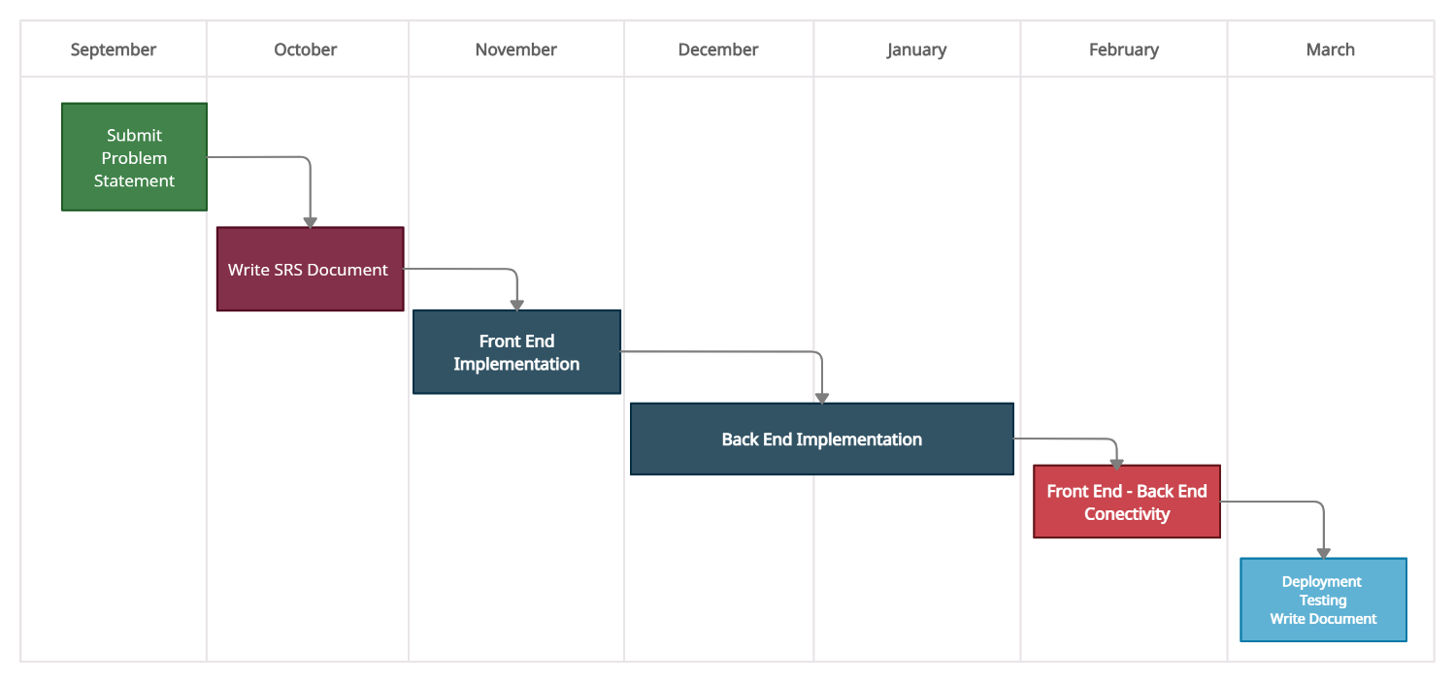

**Figure 3.1 Timeline Chart**

## **3.2.3 Project Table**

Project table is a tabular listing of all project tasks, their planned and actual start- and end-dates, and a variety of related information. Used in conjunction with the timline chart, project tables enable the project manager to track progress.

**Table 3.2 Project Table**

|  |  |  |  |  |  |
| --- | --- | --- | --- | --- | --- |
| **Event Name** | **Start Date** | **Actual**  **Start**  **Date** | **End Date** | **Actual**  **End**  **Date** | **Effort Assignment** |
| **Problem Definition**  -Collecting detailed problem definition of the system to be implemented | Oct 14  2021 | Oct 15 2021 | Oct 19 2021 | Oct 19 2021 | All |
| **Initiation** (Literature Survey)  -Visiting different websites.  -Studying existing system with its limitation  -Going through Journals, magazines  -Studying the reference books | Oct 21  2021 | Oct 21  2021 | Oct 23  2021 | Oct 27  2021 | Jayesh Patil |
| **Feasibility Study**  -Technical & Economical feasibility | Oct 28 2021 | Oct 29 2021 | Nov 03 2021 | Nov 01 2021 | Lalit Nikam |
| **Project Planning & Scheduling**  -Prepare complete project plan: decide Roles,  Schedule of events, Deadlines | Nov 05 2021 | Nov 05 2021 | Nov 22 2021 | Nov 10 2021 | All |
| **Requirement Analysis**  -Functional & Non-Functional Requirements  -Software & Hardware Requirements | Nov 12 2021 | Nov 13 2021 | Nov 17 2021 | Nov 17 2021 | Rushikesh  Patil |
| **Estimations**  -Estimate Size, Effort, Duration, Person & Cost of for the project | Nov 19 2021 | Nov 19 2021 | Nov 22 2021 | Nov 21 2021 | All |
| **Modelling**  -Describing relationships between modules and sub modules  -Describe the schema of database and the relationship between the various entities in it | Dec 02  2021 | Dec 02  2021 | Dec 11  2021 | Dec 10  2021 | All |
| **Design**  -Design various UML Models | Dec 09 2021 | Dec 09 2021 | Dec 12 2021 | Dec 12 2021 | Milind Mahire |
| **Project-I Documentation**  -Prepare Expected Result, Conclusion and  References Compile all data into a report  -Prepare Presentation | Dec 23 2021 | Dec 23 2021 | Dec 28 2021 | Dec 28 2021 | All |
| **Form Design**  -Design the graphical user interface (GUI) of the various modules, show relationship among them. | Jan 01  2022 | Jan 03  2022 | Jan 15  2022 | Jan 15  2022 | All |

# **3.3 REQUIREMENT ANALYSIS**

We have identified some requirements during the requirements collection phase;

* User means people check the symptoms , View all diseases information, search disease information using text enter otherwise speak and they also post questions and give the feedback.
* Doctors can register themself also login. They can add disease details, update details,delete details. They solve people's questions.
* Admin can be verifying the register doctor details. Also they can verify diseases with added details. Also see all the user details and doctors details. Manage site settings.

## **3.3.1 Software Process Model**

There are many different software development life cycle models. They represent the logical constructed sequence of actions, starting with the need identification and finishing with the software production. Each model represents the process, which consists of the stages aimed at ensuring the integrity of the appropriate actions. Each fully exhaustive stage reduces the degree of project risk due to the application of the criteria of entry and exists to determine the future actions.

The software development life cycles are the techniques, which cover all standards and procedures which impact on the planning, requirements process, design, construction ( coding and testing), implementation of the software system. The popular generalized models provide only possibility of its use for certain project types. The life cycle must be carefully selected according to tasks and goals of the certain project to ensure the efficiency of the life cycle.

We are the select waterfall life cycle model because all requirements are easy to understand and also development team members have less domain knowledge.

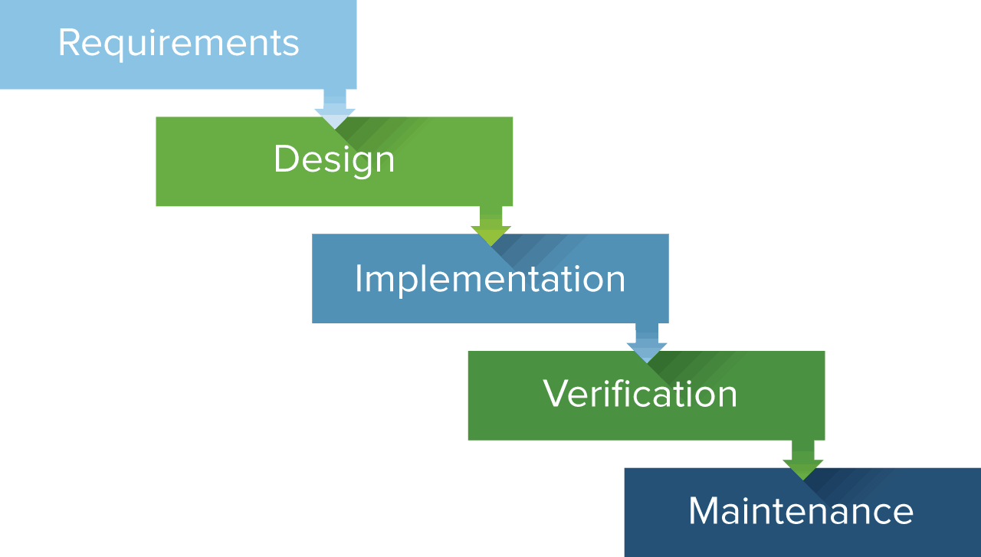

**Figure 3.2 Waterfall Model**

## **3.3.2 Functional Requirements**

A functional requirement defines a function of a software system on its component. A function is described as a set of in out, the behaviour and output. Functional requirements may be calculations, technical details, data manipulation and processing and other specific functionality that defines what a system is supposed to accomplish.

This platform doctors and people  join and the people check their symptoms, post questions and perform this activity. Doctors are added to the disease information, answers to asked questions also admin verify doctors details these are our project function requirements.

## **3.3.3 Non-functional Requirement**

Nonfunctional requirements deny the needs in terms of performance, logical database requirements,design constraints, standard compliance, reliability, availability, security, main- tainability and portability.

A non-functional requirement is a requirement that specific criteria that can be used to judge the operation of a system, rather than specific behaviors. It should be contrasted with functional requirements that define specific behavior or functions. The plan for implementing functional requirements is detailed in the system design. The plan for implementing non functional requirements is detailed in the system architecture.

## **3.3.4 Hardware Requirements**

* **System** : Any.
* **RAM** : 4 Gb or above
* **Hard Disk** : 1Tb or above
* **Input Device** : Keyboard or Mouse
* **Output Device** : Monitor, PC or Laptop.

## **3.3.5 Software Requirement**

* **Operating System**: Any.
* **IDE**: Visual Studio Code
* **Front End**: HTML, CSS, Java Script
* **Back End:** Node Js
* **Library:** React Js, Chart Js.
* **FrameWork:** Express
* **Ui FrameWork:** React-Bootstrap
* **Database:** MongoDB
* **Project Managed**:GitHub
* **Deployment:** Netlify, Heroku

# **3.4 ANALYSIS MODELING**

## **3.4.1 System Architecture**

The system architecture is the conceptual model that denotes the structure, behavior and more views of a system. An architecture description is a formal description and representation of a system. It provides a broad understanding of the portal.

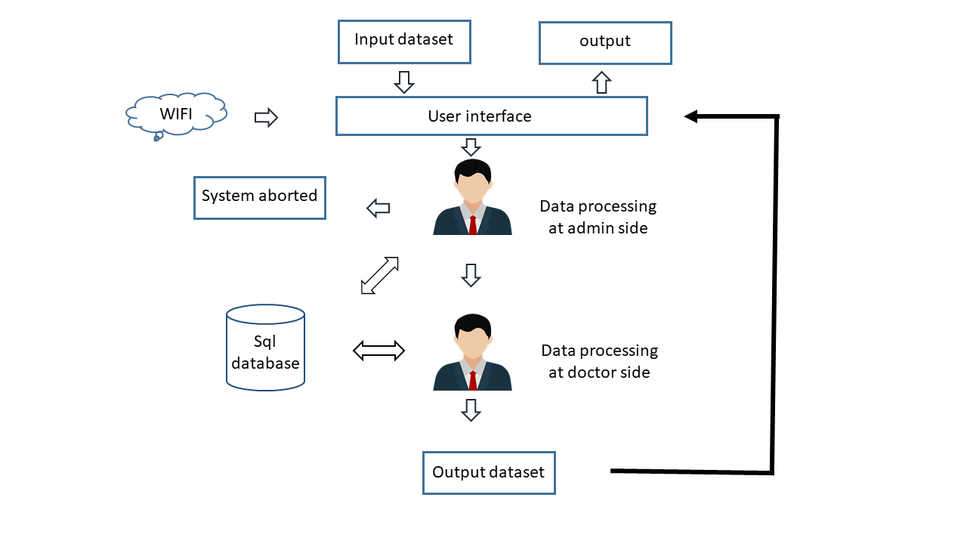

**Figure 3.3 System Architecture**

## **3.4.2 E-R Diagram**

An entity–relationship model (or ER model) describes interrelated things of interest in a specific domain of knowledge. A basic ER model is composed of entity types (which classify the things of interest) and specifies relationships that can exist between entities (instances of those entity types).In software engineering, an ER model is commonly formed to represent things a business needs to remember in order to perform business processes. Consequently, the ER model becomes an abstract data model that defines a data or information structure which can be implemented in a database, typically a relational database.

In This project use database structure mentioned in figure 3.5. The database structure defined Like Entity people this entity attributes like name, id is primary key, email, address, password like this all database structure defined.

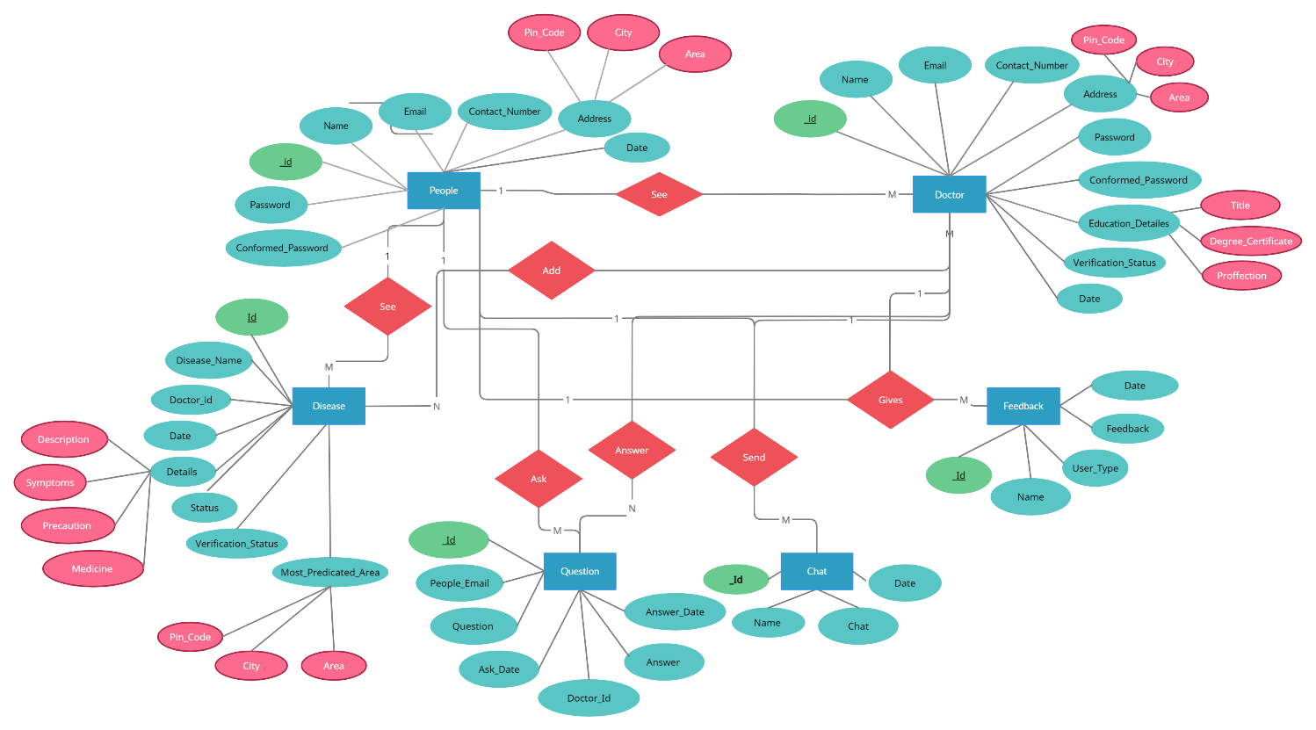

**Figure 3.4 ER Diagram**

## **3.4.3  Data Flow Diagram**

DFD is concerned with designing a sequence of functions that converts the system input into the required output.

### **3.4.3.1  level 0 DFD**

Level 0 contains one input and one output. The system provides information to the user means the system is input and the user is output.

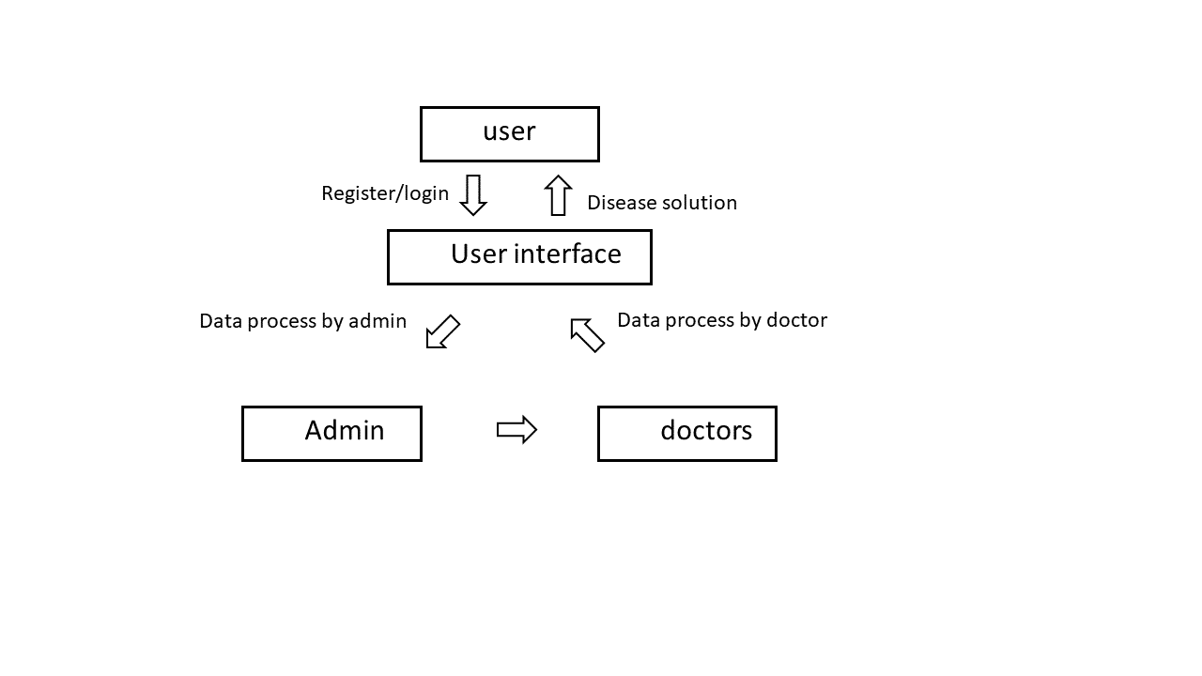

**Figure 3.5 Level 0 DFD**

### **3.4.3.1  level 1 DFD**

Scheme management helps to generate the scheme and criteria management helps to provide the information according to the user's criteria.

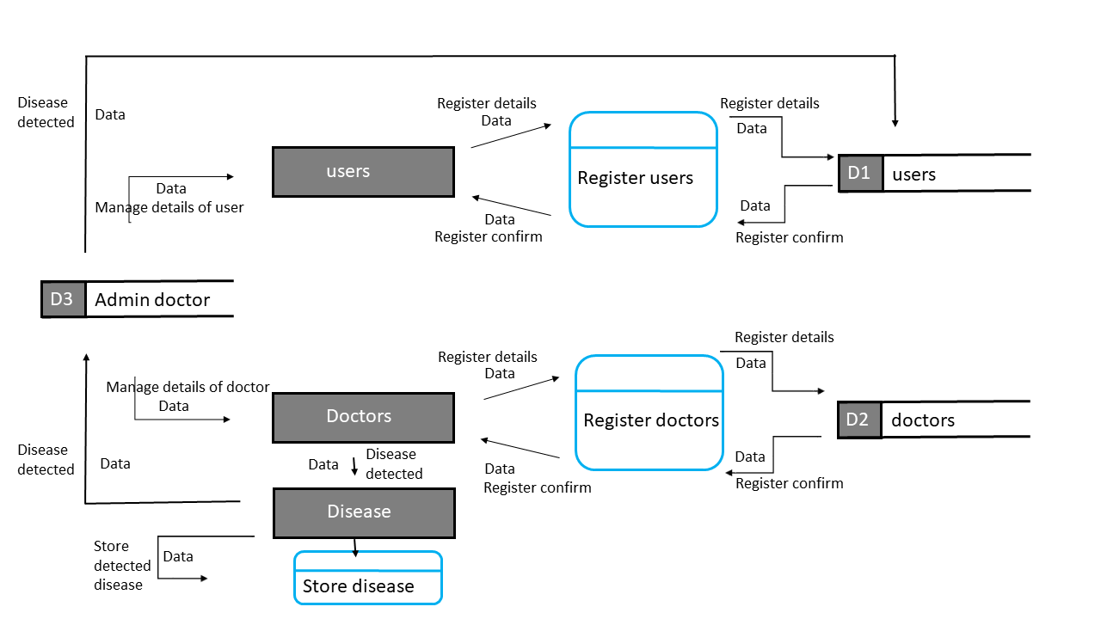

**Figure 3.6 Level 1 DFD**

Chapter 4

DESIGN

# **4.1 INTRODUCTIONS**

System design provides the understanding and procedural details necessary for implementing the system. Design is an activity concerned with making major decisions, often of a structural nature. Design builds coherent, well planned representations of programs that concentrate on the interrelationships of parts at the higher level and the logical operations involved at the lower levels. Software design is the rest of the three technical activities: designs, coding and tests which are required to build and verify the software.

**4.2 UML MODELING**

The Unified Modeling Language is a language that defines the industry's best engineering practices for the modeling systems. The goal of UML is to be a ready-to-use expressive visual modeling language that is simple and extensible. Use case diagram shows a set of use cases, actors and their relationships. Use case diagrams address the static use case view of a system. These diagrams are especially important in organizing and modeling the behaviour of the system.

Subsection 4.1 shows the use case  diagram. Sequence diagrams show the subsection 4.2. Subsection 4.3 shows the collaboration diagram. Activity diagrams show the subsection 4.4. Subsection 4.5 shows the class diagram. Components diagram shows the subsection 4.6. Subsection 4.7 shows the state chart diagram. Finally subscription 4.8 shows the deployment diagram.

## **4.2.1 Use Case Diagram**

The Use Case diagram of the project disease prediction system consists of all the various aspects a normal use case diagram requires .The use case diagram shows the various actors like users ( Peoples ), Doctors, admin doctor and the relation and dependency between them. It also shows the functionality of the entire system.

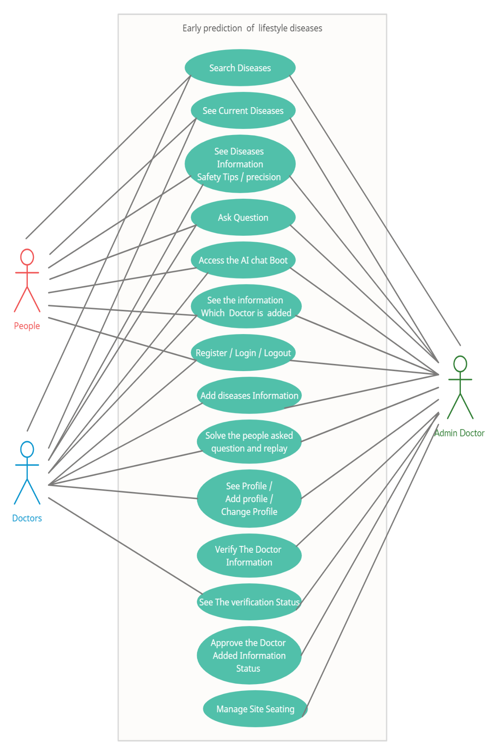

**Figure 4.1 Use Case Diagram**

## **4.2.2 Sequence Diagram**

The Sequence diagram of the project disease prediction system consists of all various aspects a normal sequence diagram requires.

The Figure 4.2. shows the sequence of interaction between the various objects like login, register and logout functionalities. The Figure 4.3 shows the sequence of interaction between the user ( people ) Interaction to the portal. The Figure 4.4 shows the sequence of interaction between the Doctors Interaction to the portal. The Figure 4.5 shows the sequence of interaction between the Admin Doctors Interaction to the portal.

### **4.2.2.1 Register Login Logout**

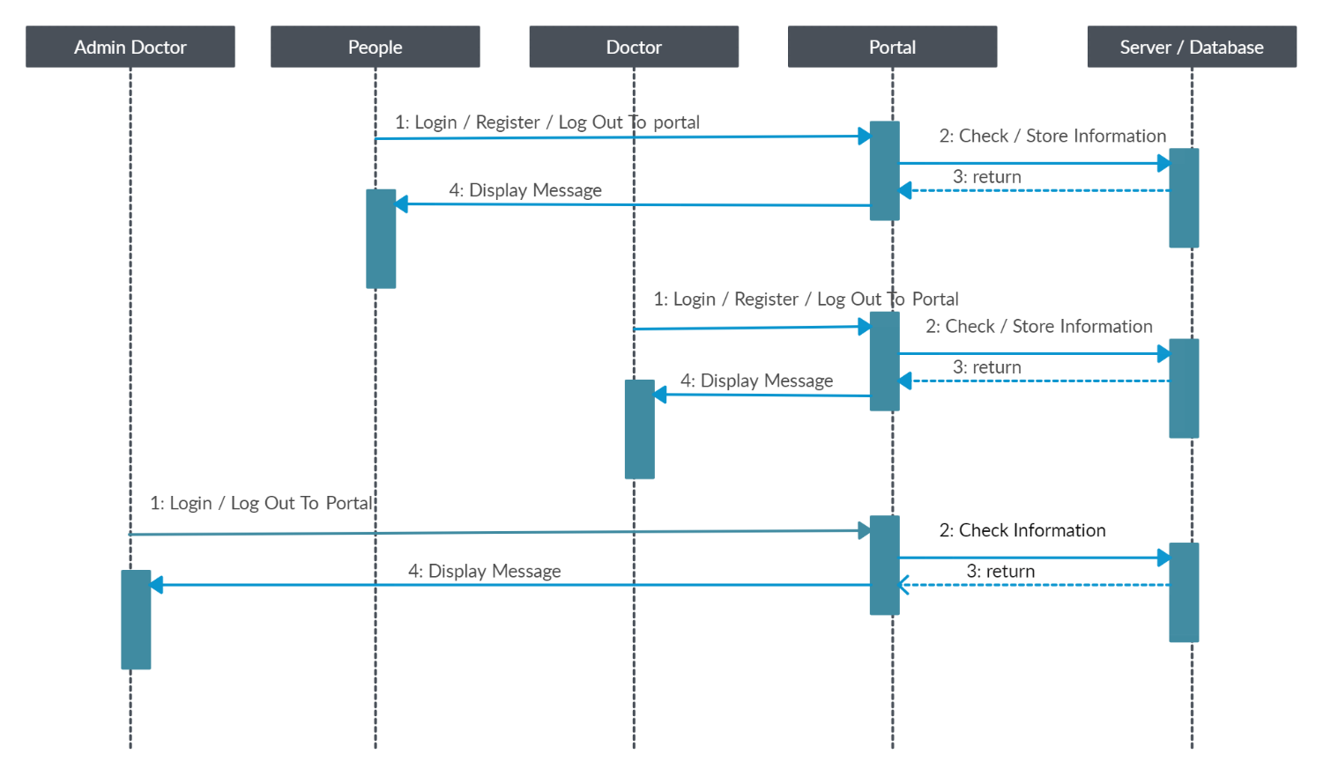

**Figure 4.2 Register Login Logout**

### **4.2.2.2 User ( People ) Sequence Diagram**

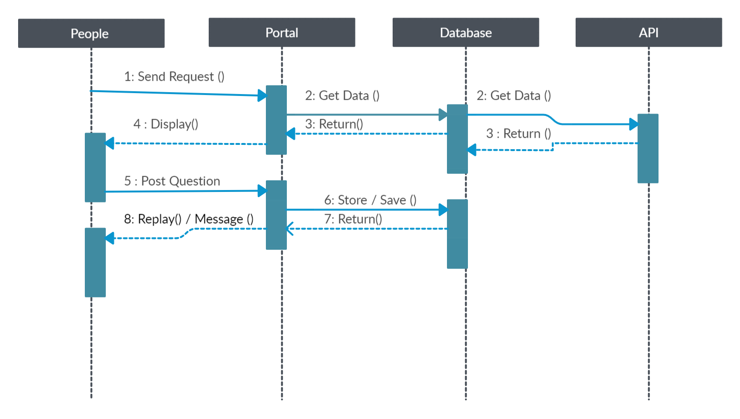

**Figure 4.3 User ( People ) Sequence Diagram**

### **4.2.2.3  Doctors Sequence Diagram**

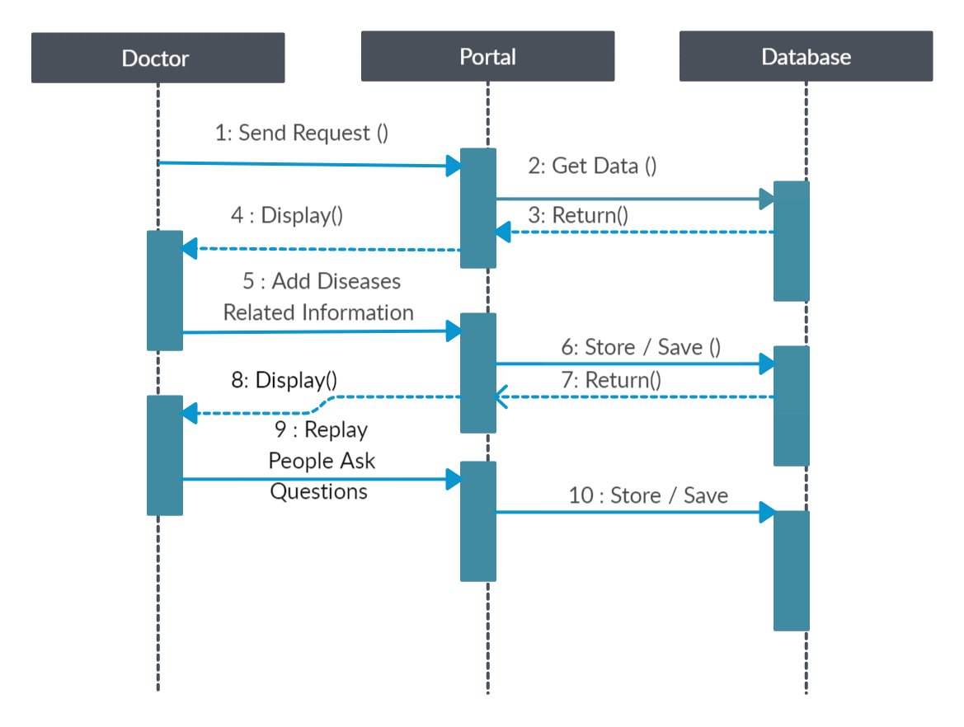

**Figure 4.4  Doctors Sequence Diagram**

### **4.2.2.4  Admin Sequence Diagram**

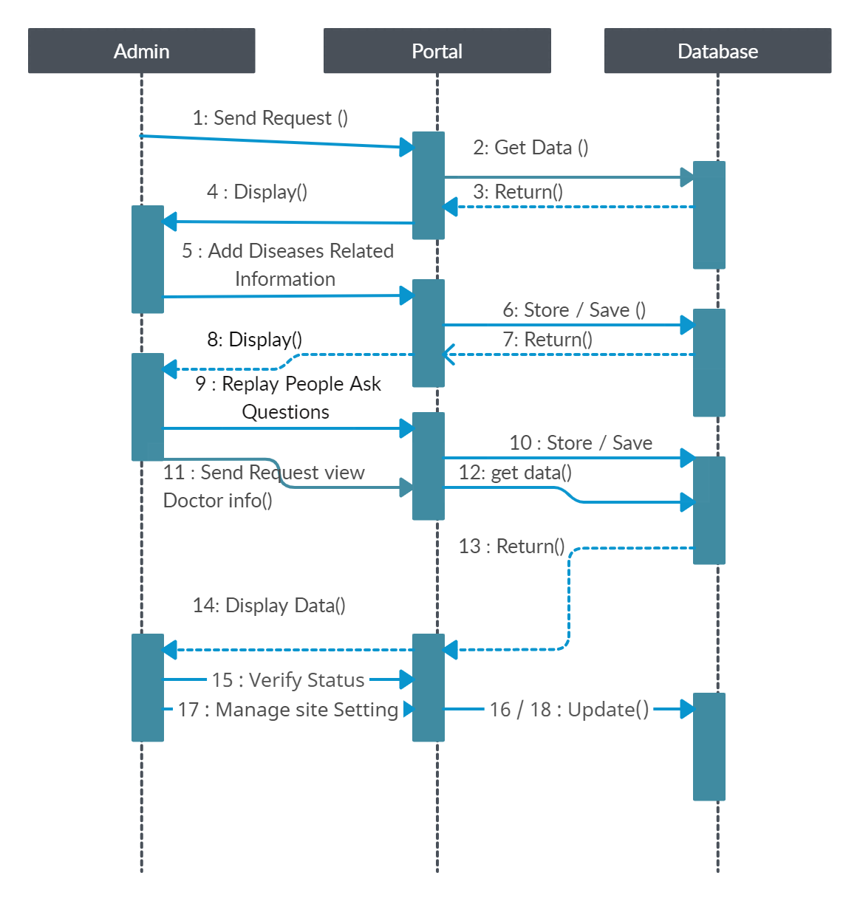

**Figure 4.5   Admin Sequence Diagram**

## **4.2.3 Collaboration Diagram**

A collaboration diagram, also known as a  communication diagram, is an illustration of the relationships and interaction among software objects in the UML. These diagrams can be used to poetry the dynamic behaviour of a particular use case and define the role of each object.

Here this figure 4.5 shows how all the modules are connected to shoes the correct result starting from people, where the opens the portal then using the portal he does registration and the registration data is saved into database and using those data people / admin logs to the portal and then he provides all the necessary information in order to get the accurate result, then portal evaluates the people / admin entered information and finally gives the correct result.

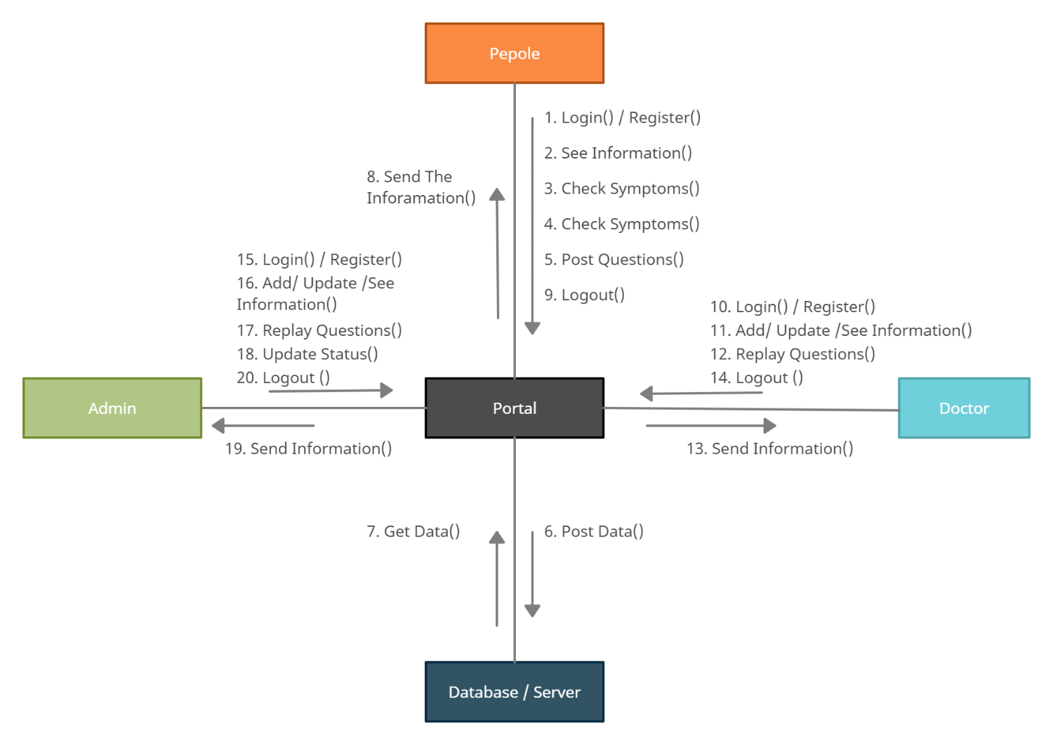

**Figure 4.6   Collaboration Diagram**

## **4.2.4 Activity Diagram**

Activity diagram is another important diagram UML describes the dynamic aspect of the system. Activity diagram is basically flowchart to represent the flow from one activity to another activity. The activity can be described as an operation of the system. The control flow is drawn from one operation to another

Here in the figure 4.7 describe user view activities starts from checking symptoms and also search disease like this. And figure 4.8 describes admin view activities starting from login like this.

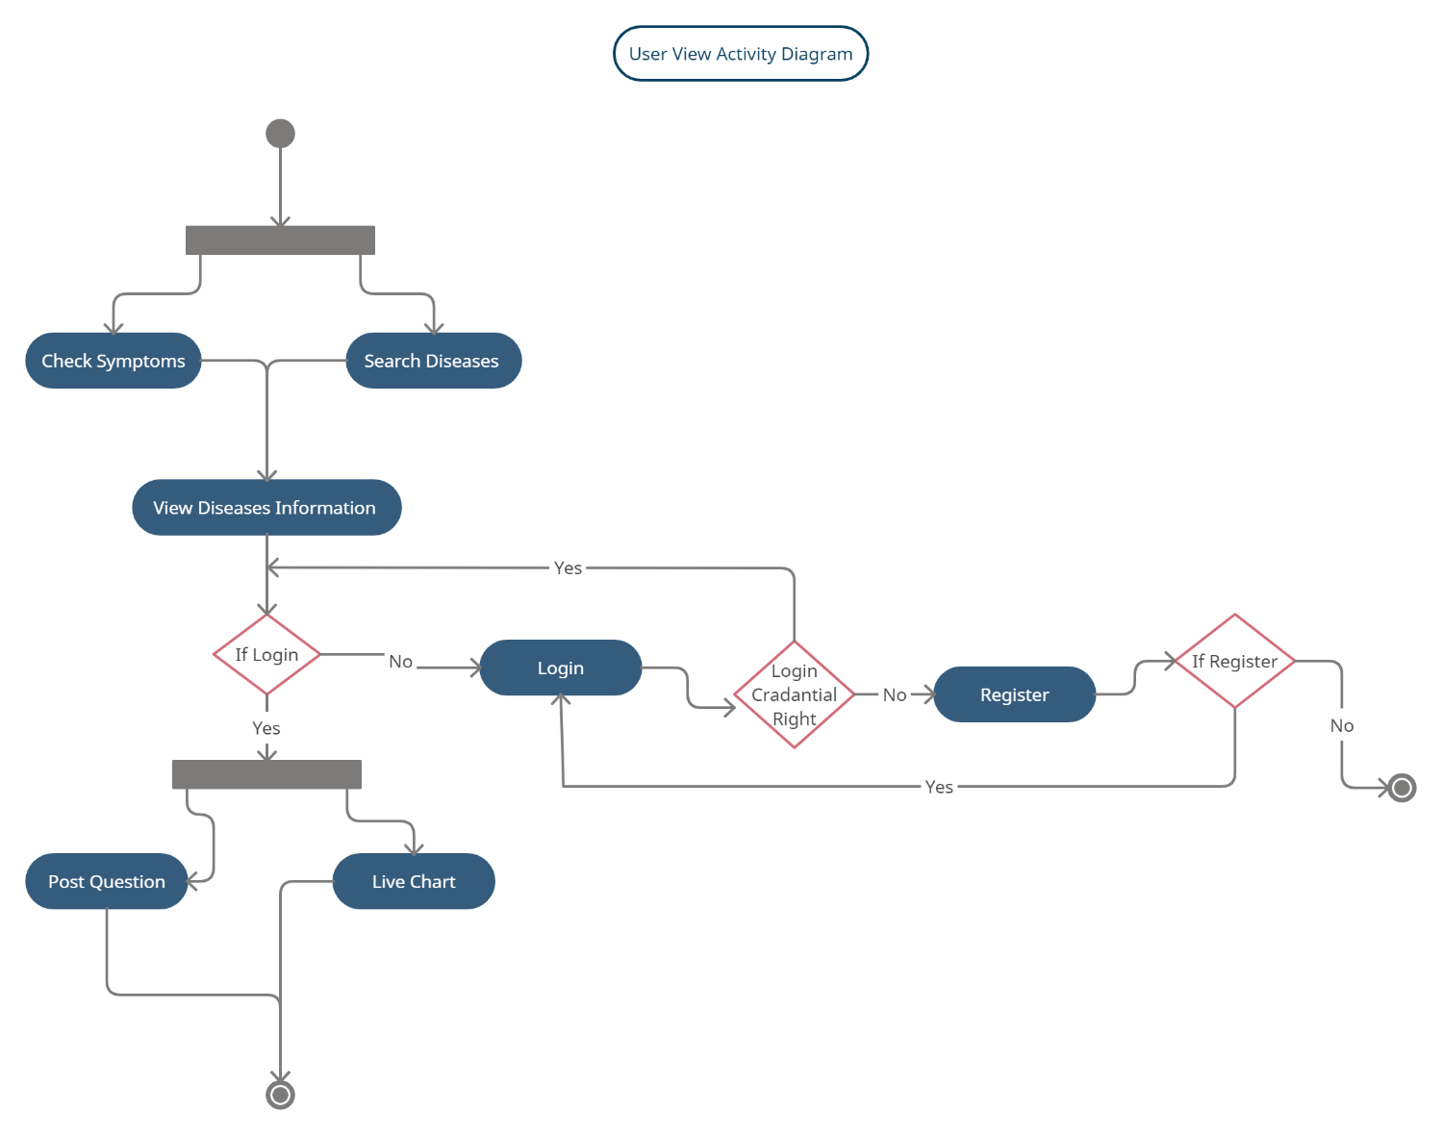

**Figure 4.7   User View Activity Diagram**

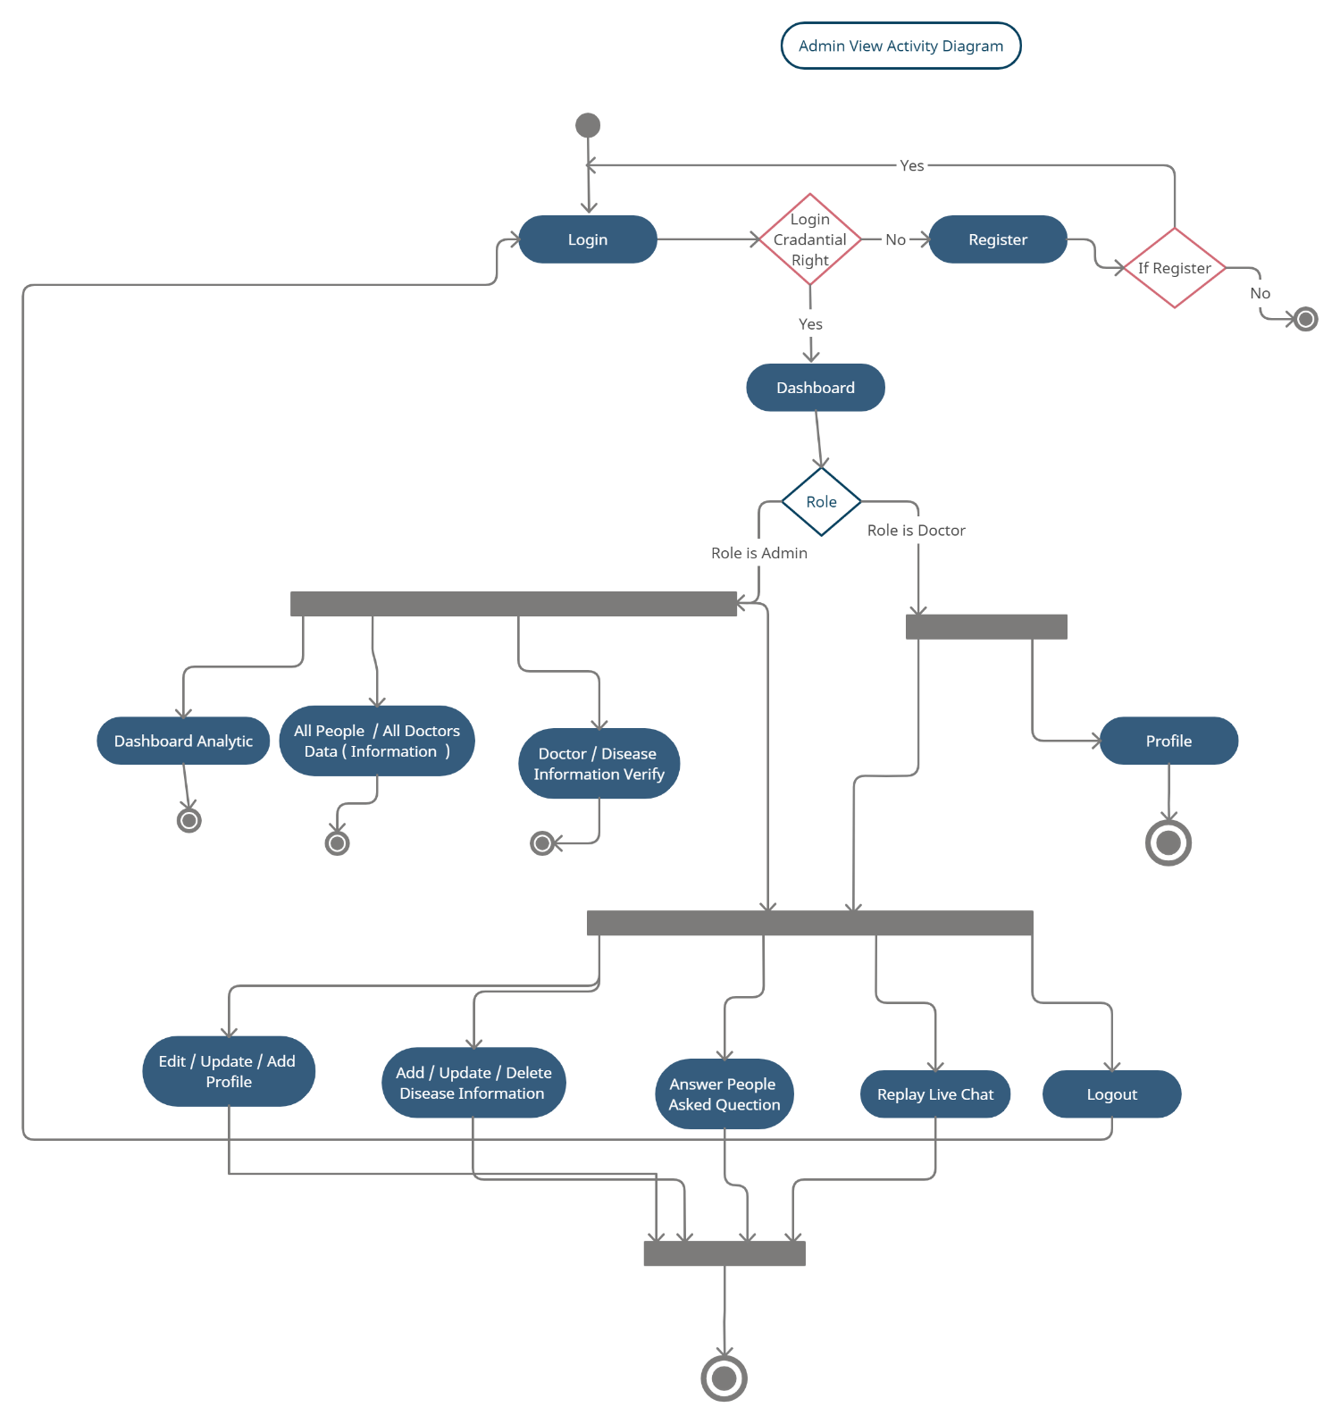

**Figure 4.8  Admin View Activity Diagram**

## **4.2.5 Class Diagram**

Disease prediction system consists of a class diagram that all the other applications that consist of the basic class diagram, here the class diagram is the basic entity that is required in order to carry on with the project. Class diagram consist information about all the classes that is used and all the related datasets, and all the other necessary attributes and their relationships with other entities, all these information is necessary in order to use the concept of the prediction, where the people will enter all necessary information such as name,email,contact number, and many more attribute that is required in order to login into the system and using the database we will store the information of the people, admin, doctors who are register into the system and retrieves those information later while logging into the system. The figure 4.9 shows a class diagram of the overall system.

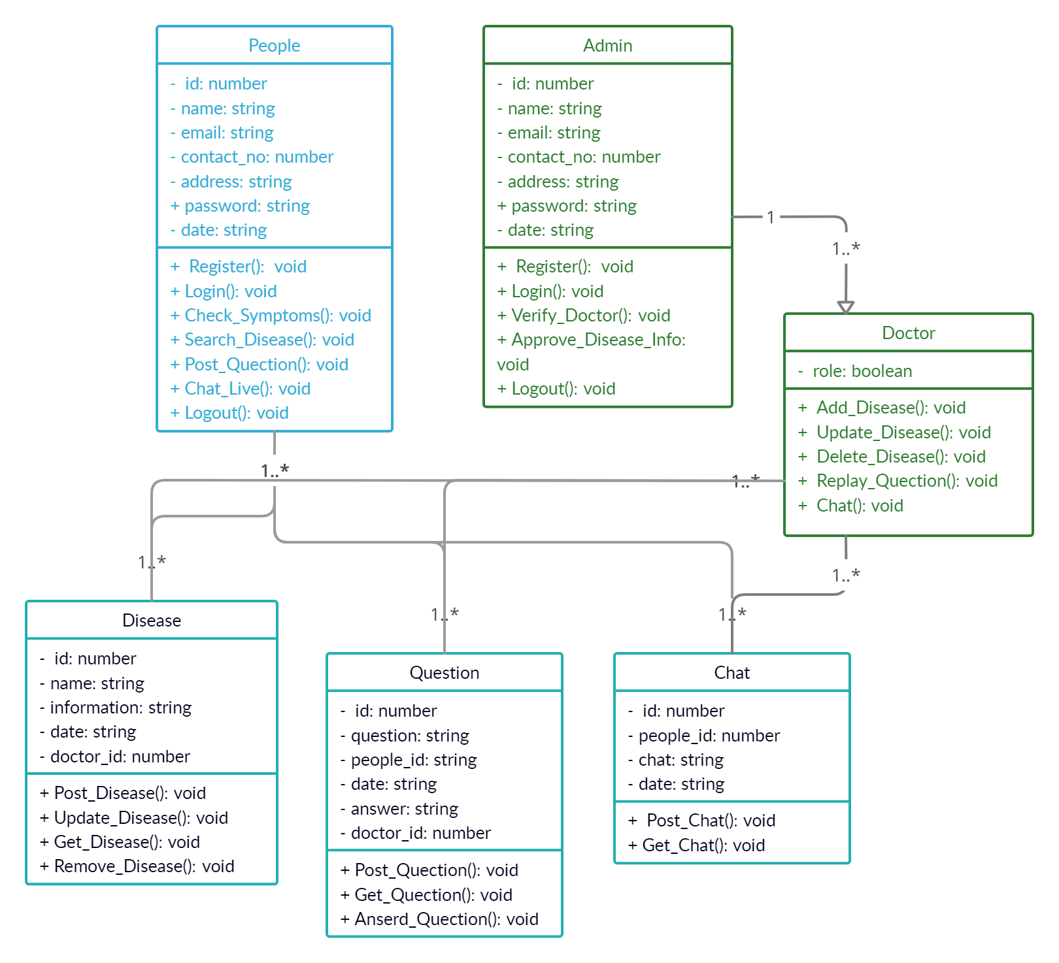

**Figure 4.9  Class Diagram**

## **4.2.6 Component Diagram**

A components diagram, also known as a UML component diagram, describes the organization and writing of the physical components in a system. Component diagrams are often drawn to help model implementation details and double-check every aspect of the system’s required function is covered by planned development. Here the component diagram consists of all major components that are used to build a system. Figure 4.10 describes the components diagram.

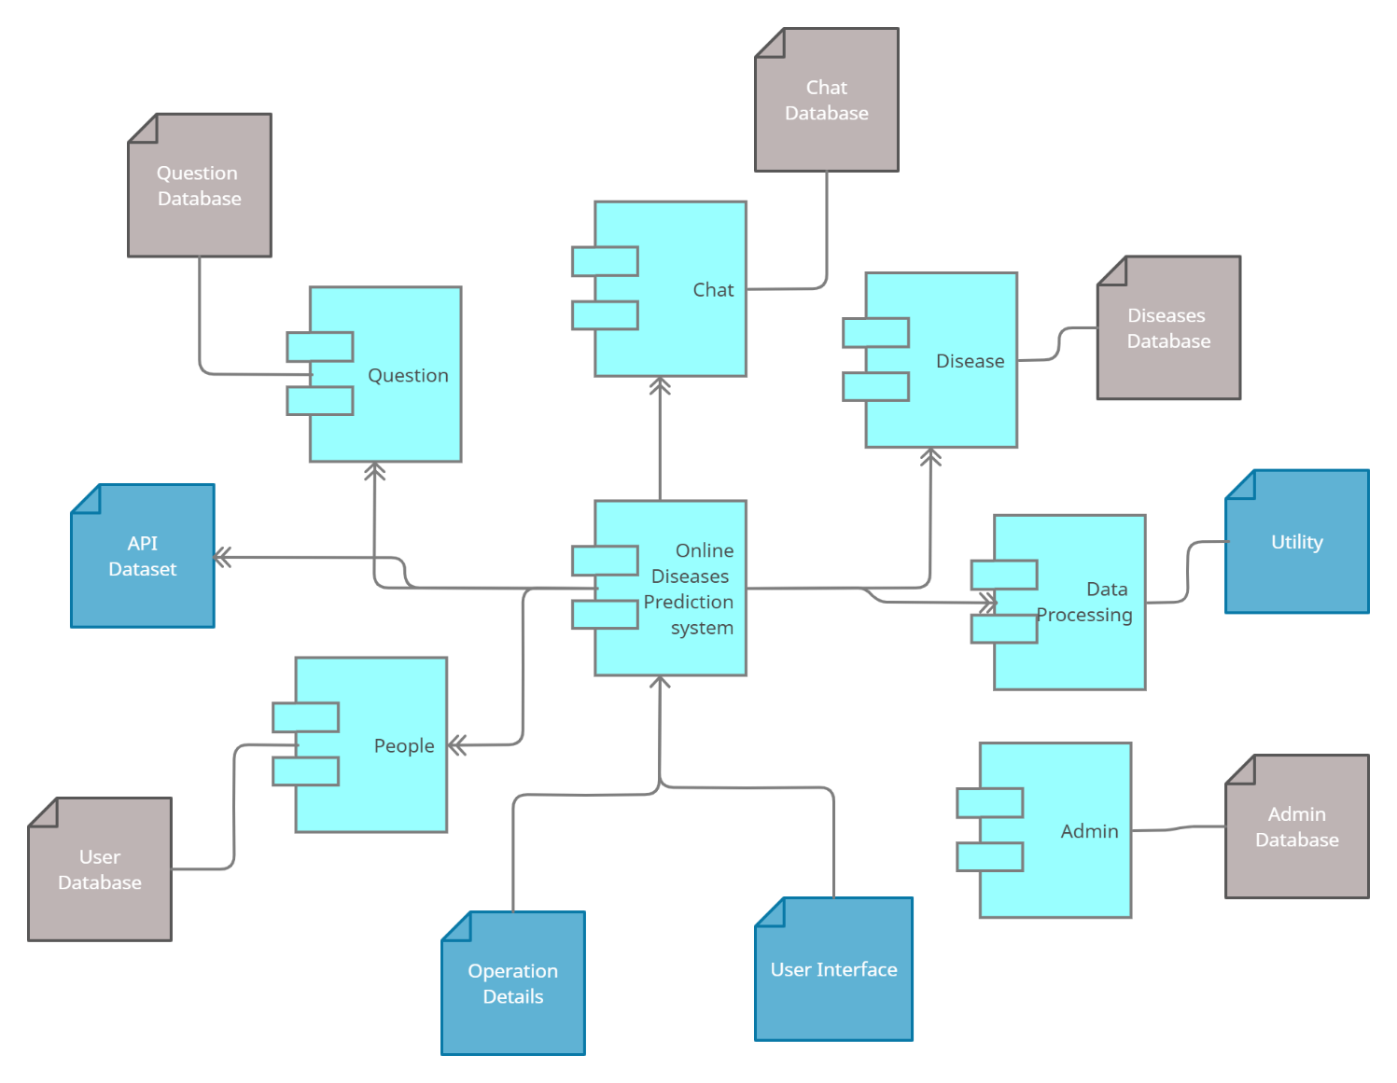

**Figure 4.10  Component Diagram**

## **4.2.7 Deployment Diagram**

A deployment diagram shows the  configuration of run time processing nodes and the components that live on them. Deployment diagram is a kind of structure diagram used in modeling the physical aspect of an object-oriented system. Here the deployment diagram shows t5he final stage of the project and it also shows how the module looks after doing all the process and deploying in the machine. Starting from the system, how it processes the people entering information and then comparing that information with the help of datasets, then training and testing that data using the algorithms such as decision tree, naive Bayes, random forest. Then finally processing all those data and the information the system gives the desired result in the interface.

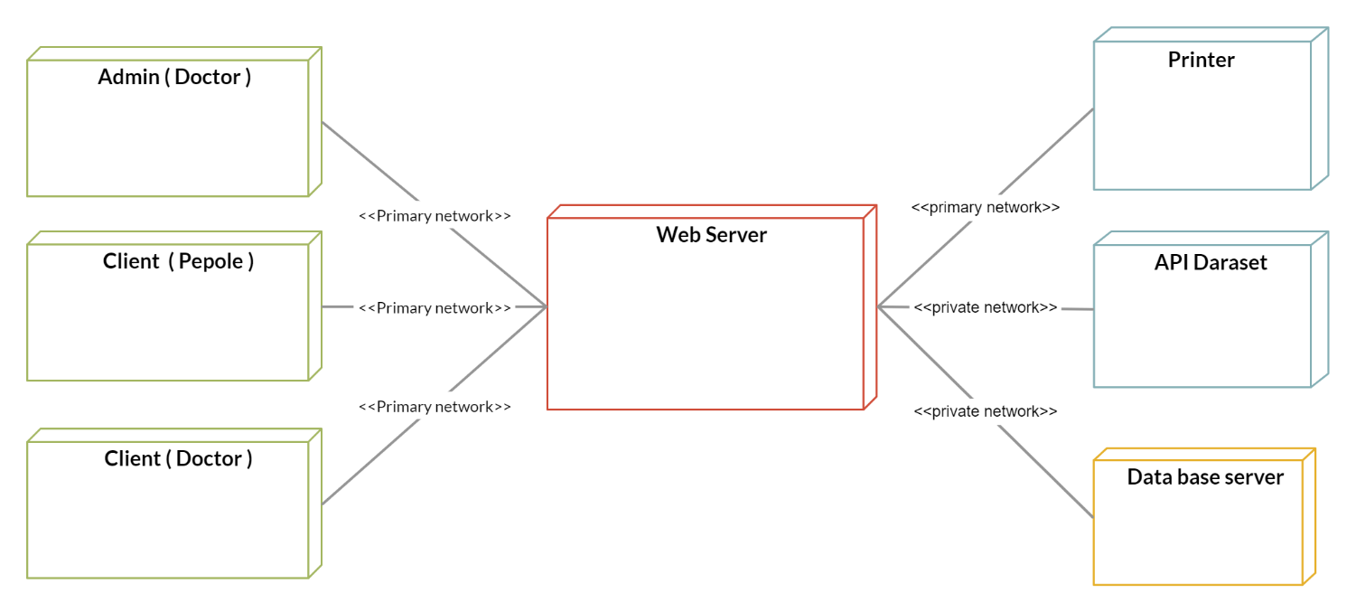

**Figure 4.10  Deployment Diagram**

Chapter 5

CONCLUSION

# **5.1 CONCLUSION**

So, Finally we conclude by saying that, this project early prediction of lifestyle diseases .learning is very much useful in everyone’s day to day life and it is mainly more important for the healthcare sector, because they are the one that daily uses these systems to predict the diseased of the patients based on their general information and there symptoms that they are been through. Now a day’s health industry plays major role in curing the diseases of the patients so this is also some kind of help for the healthy industry to tell the people and also it is useful for the user in case he/she doesn't want to go to the hospital or any other clinics, so just by entering the symptoms and all other useful information the user can get to know the disease he/she is suffering from and the health industry can also get benefit from this portal by just asking the symptoms from the user and entering in the system and in just few seconds they can tell the exact and up to some extent the accurate diseases. If the health industry adopts this project then the work of the doctors can be reduced and they can easily predict the disease of the patient. The Disease prediction is to provide prediction for the various and generally occurring diseases that when unchecked and sometimes ignored can turn into fatal disease and cause a lot of problems to the patient and as well as their family members.

# **5.2 FUTURE WORK**

Our team is planning in the future to implement an overall system.

REFERENCES

1. C. T. Butts and M. Petrescu-Prahova, \Radio communication networks in the world trade center disaster," http://gladiator.ncsa.uiuc.edu/PDFs/networks/butts-radio.pdf,Apr 2005.
2. S. S. Kulkarni, M. G. Gouda, and A. Arora, \Secret instantiation in ad-hoc networks," Computer Communications, vol. 29, no. 2, pp. 200{215, 2006.
3. C. K. Wong, M. Gouda, and S. S. Lam, \Secure group communications using key graphs," SIGCOMM Com put. Commun. Rev., vol. 28, no. 4, pp. 68{79, 1998.
4. <https://en.wikipedia.org/wiki/Entity%E2%80%93relationship_model>
5. N. R. Adam and J. C. Wortmann, `Security Control Methods for Statistical Databases: A Comparative Study' , ACM Computing Surveys, vol. 21, no. 4, pp. 515-556, 1989.